# Lab: Introduction-to-Hibernate – MiniORM (Annotations)

# Problems for exercises and homework for the

# ["DB Advanced" course @ SoftUni](https://softuni.bg/trainings/1635/databases-frameworks-hibernate-and-spring-data-june-2017).

Following guides of this document is continuation of previous lab where we created custom ORM with basic functionality (insert, update and retrieve single object or set of objects). In this lab we need to enhance out ORM implementation to use Annotations.

## Create Annotations

In previously created Project MiniORM, add package **persistence** to keep our annotations that would be required for our ORM. Create 3 annotations:

* **Id** – has no properties, it will be applied on **fields only**
* **Column** – has property **name**, it will be applied on **fields only**
* **Entity** – has property **name**, it will be applied on **classes only**

Follow the good practices in naming custom annotations.

## Create Entities

To the previously created class **User** add appropriate **annotations** like shown below:

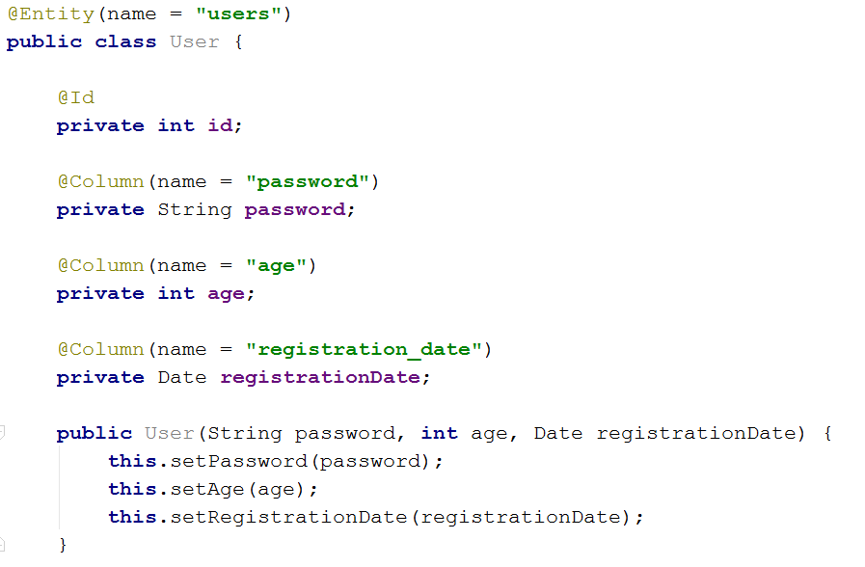

## Enhance EntityManager

Enhance already created class EntityManager to read annotations by reflection and use the provided metadata from annotations. Provide helper methods inside EntityManager for reading table name, column names and Id considering annotations :

* **private <E> String tableName(E entity)** – Returns the value of the **name** type of Entity annotation or if it’s not set returns the name of the entity.
* **private String columnName(Field field)** – Returns the value of the **name** type of Column annotation or if it’s not set returns the name of the field.
* **private boolean isPrimaryKey(Field field)** – checks if a given field is annotated with Id annotation.
* **private <E> void checkPrimaryKey(E entity)** check if there is at least one field annotated with Id annotation of the given entity. If there is no field with Id annotations throw IllegalStateException. This method should be called before table creation.

